**ESSEX COUNTY**

**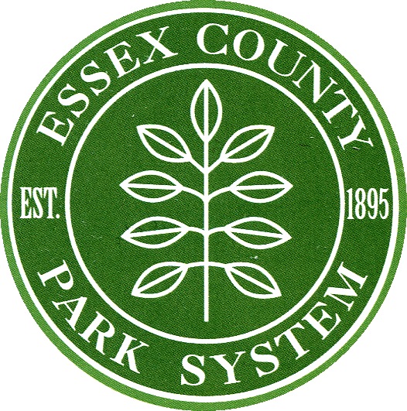****LOCAL ARTS & HISTORY GRANTS PROGRAM**

**2020 GUIDELINES**

**FUNDING PERIOD: January 1, 2020 – December 31, 2020**

**All expenditures must occur between these dates.**

**APPLICATION PROCESS BEGINS: June 1**

**Applications are available at** [**www.essexcountynj.org**](http://www.essexcountynj.org) **.**

**DEADLINE FOR SUBMISSION: Monday, August 5, 2019 at 9:00am**

**AWARD LETTERS SENT: December**

**SIGNED GRANT CONTRACT DUE: December 31**

**FIRST 75% of GRANT AWARDED: upon approval by Board of Chosen Freeholders**

**INTERIM REPORT DEADLINE: July 15of grant year**

**FINAL REPORT DEADLINE: January 13of grant year**

**FINAL 25% of GRANT AWARDED: upon receipt of final report**

**TYPES OF GRANTS**

Applicants may apply for only one type of grant (GOS or SPS).

**General Operating Support (GOS) Grants** are available to support the overall operations of non-profit organizations whose missions are exclusively devoted to history. Requests for funding may not exceed 20% of the applicant’s annual expense budget. These grants are non-restricted, non-project funds. GOS grants must be matched one dollar for every dollar awarded (1:1)*.

**Special Project Support (SPS) Grants** are available to support the cost of a history-related special project of the applicant. The special project must be wholly dedicated to local or New Jersey history and be a project or program open to the general public. Requests can be made for up to 50% of the special project’s expenses. SPS grants must be matched one dollar for every dollar awarded (1:1)*.

*At least half of the match must be cash; no more than half can be in-kind.

**HOW TO APPLY**

The web-based application for the upcoming funding period will be made available on June 1 on the Essex County webpage at <https://www.essexcountyparks.org/cultural/grants>. Upon clicking the Grant Interface, applicants will be prompted to log in. (New applicants must first register and set up their login id.) Applicants must next select either the Local History or Local Arts Grant Program. After selection, applicants can begin completing the application.

**Submissions must be made by 9:00 am on Monday August 5, 2019. Extensions cannot be granted; plan accordingly. If you have problems submitting your application, contact Kathy Kauhl at 973-735-6231 before the deadline.**

**APPLICANT ELIGIBILITY**

All applicants must:

* Be located in Essex County and primarily serve the constituency of Essex County.
* Be incorporated in the State of New Jersey as a non-profit corporation or a unit of government.
* Be tax exempt as determined by the Internal Revenue Service in accordance with IRC 501(c)3 or (c)4.
* If History: May not be receiving funding from the New Jersey Historical Commission or from another county historical affairs agency.
* If Arts: May not be receiving funding from the New Jersey State Council on the Arts or from another county arts agency.
* Be in compliance with all pertinent State and Federal regulations including, but not limited to:
* Civil Rights Act of 1964 which bars discrimination based on race, color, national origin, sex and disability.
* Americans with Disabilities Act (ADA) which requires all providers of public programs and services to ensure that those programs and services can be enjoyed by all citizens, including those with disabilities.

**ADA COMPLIANCE**

Ensuring historic programming supported by Essex County is available to the widest possible audience is a high priority for the Division of Cultural and Historic Affairs. This includes access for people with disabilities. Accessibility includes the physical performance/exhibition space (whether owned, rented or free), programming, audience and audience development, marketing, sensitivity training for staff, and printed materials.

**THIS GRANT WILL NOT FUND**

* Capital improvements and acquisitions
* Hospitality costs and foreign travel
* Deficits
* Student publications, student performances and scholarships
* Projects in educational or religious institutions which primarily involve students or members and do not involve the public at large. Programs must be supplemental to any curriculum and separate from any religious observance.
* Fundraising events
* Restoration or preservation of buildings/structures
* If History: Organizations receiving grant funds from the New Jersey Historical Commission or another county cultural and historical affairs agency
* If Arts: Organizations receiving grant funds from the New Jersey State Council on the Arts or another County Arts Agency

**GRANT PROCESS**

* Division of Cultural Affairs staff will review proposals, checking for completeness and eligibility.
* Complete and eligible applications will be submitted to an independent peer panel of history professionals for evaluation.
* Your organization will be invited to meet briefly with peer panel in September
* The Essex County Cultural & Heritage Affairs Advisory Board will meet and review the recommendations and evaluations of the peer panel and determine grantee funding levels based upon funds available from the state.
* Successful applicants receive an award letter and grant contract in December.
* Completed contracts are submitted to the Board of Chosen Freeholders for approval.
* Upon approval of signed contracts, the first payment (75% of the grant award) is disbursed.
* An interim report must be submitted mid-year to show progress.
* The final payment (25% of the grant award) is disbursed upon receipt and approval of a final report at the conclusion of the funding period.

**APPEAL PROCESS**

A written appeal may be filed if an applicant can demonstrate an application was misinterpreted or misunderstood during the initial evaluation process. The amount of an award is not grounds for an appeal and an appeal must be made only on the basis of the information contained in the initial application.

**ESSEX COUNTY LOCAL HISTORY GRANT**

**HISTORY EVALUATION CRITERIA**

History grant applications are evaluated based upon the following criteria:

* Clarity of mission, long-term goals, and relevance to New Jersey history
* Quality of New Jersey history programs and means of evaluation
* Public benefit, audience, marketing, and commitment to increasing diversity and accessibility
* Evidence of community support
* Commitment to promoting education and advocacy of New Jersey history
* Quality of governance, management, staff and operations
* Financial soundness and accountability
* For organizations with historic collections and/or buildings, evidence of responsible stewardship of collections or property

For more information on the Caucus Archival Projects Evaluation Service (CAPES) or the free Artifact Assessment Program (AAP) please see the following link:

<https://nj.gov/state/historical/his-grants.shtml>

**Do you have questions regarding the Local History Grant Program?**

**Please contact Kathy Kauhl at 973-735-6231 or kkauhl@parks.essexcountynj.org.**

**LOCAL HISTORY GRANT PROGRAM**

**LOCAL ARTS GRANT PROGRAM**

**ARTS EVALUATION CRITERIA**

Applicants are evaluated based upon the following criteria:

**PUBLIC BENEFIT: AUDIENCE, OUTREACH & MARKETING**

* Impressive audience numbers
* Outreach to underserved communities
* Meets demonstrated community needs/interests
* Quality marketing materials
* Good press coverage

**ARTISTIC EXCELLENCE**

* Innovative and creative programming
* Expands artistic impact in the community
* Utilizes New Jersey artists
* Programs of high artistic quality
* Has a system to engage and evaluate artists

**ADMINISTRATIVE ABILITY**

* Effective use of requested dollars
* Correct and realistic budget
* Qualified organization capable of carrying out the proposed projects
* Qualified and capable staff
* Evidence of long-range planning (diverse funding, collaborations)

**ADA**

* Understanding of Americans with Disabilities Act
* Provides accessible programming
* Engages audiences and artists of all abilities

**FUNDING PRIORITIES**

* Engaged in collaborative partnerships
* Stimulates arts and creativity through education
* Serves the needs of artists; particularly New Jersey artists

**Do you have questions regarding the Local Arts Grant Program?**

**Please contact Kathy Kauhl at 973-735-6231 or kkauhl@parks.essexcountynj.org.**

**Do you have questions regarding the Local Arts Grant Program?**

**Please contact Kathy Kauhl at 973-735-6231 or archives@parks.essexcountynj.org.**