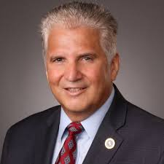
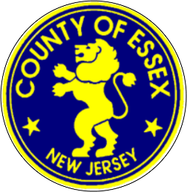
“We are excited to announce that our Learn to Skate program classes are starting back up and registration is open for skaters interested in getting back on the ice at Codey Arena. With the current Covid-19 guidelines and protocols in effect, the Arena is abiding by all the current CDC regulations in keeping everyone safe.”

Joseph N. DiVincenzo, Jr.

Joseph N. DiVincenzo, Jr., Essex County Executive
And The Essex County Board of Commissioners
Announce the return of our
LEARN to SKATE CLASSES

Codey Arena – Winter “A” Learn to Skate

REGISTRATION FOR CLASSES OPENS
MONDAY NOVEMBER 16th
Registration at:
www.essexcountyparks.org
Codey Arena

Online Registration accepted up to the day before the first day of classes
** No late registrations accepted; No refunds; No switching of classes **

Cost: $60.00 (class fee for 3 sessions, USFS fee paid from November classes & rental skates not needed)
$75.00 (class fee for 3 sessions, USFS fee paid from November classes & rental skates needed for class)
$80.00 (class fee for 3 sessions, USFS fee & rental skates not needed)
$95.00 (class fee for 3 sessions, USFS fee & rental skates needed for class)

Class Days offered: Small class sizes; socially distanced lanes

- Fridays – December 4, 11, 18
  - LTS 1A – 4:00-4:30pm LTS 1B – 4:45-5:15pm

- Saturdays – December 5, 12, 19
  - LTS 1A – 12:30-1:00pm LTS 1B – 1:15-1:45pm

- Sundays – December 6, 13, 20
  - LTS 1A – 11:30am-12:00pm LTS 1B – 12:15-12:45pm

Codey Arena recommends skaters wear a helmet, gloves & warm clothes

